LABORATORY RECORD
DSA1606 – Knowledge Engineering and Data Science

Name | Yarrapureddy Lakshmi Reddy
Register No. | 192324077
Department | AIDS
Course Code | DSA1606
Course Name | Knowledge Engineering and Data Science
Course Faculty | Dr. Sarasu Raghupathy

Contents
Exp. No. | Title of the Experiment
1 | Knowledge Representation using a Dictionary
2 | Knowledge Acquisition from a Domain Expert
3 | Course Recommendation using Rule-Based Logic
4 | Network Troubleshooting Expert System
5 | Semantic Network using NetworkX
6 | Frame Representation of Knowledge
7 | Forward Chaining Inference
9 | Knowledge Graph using NetworkX
10 | Knowledge Management System
11 | RDF Knowledge Triples using rdflib
12 | Graph Traversal – Finding the Connection between Entities

Experiment 1: Knowledge Representation using a Dictionary

Aim
To represent the knowledge about a student as structured key–value pairs using a Python dictionary and display it.

Algorithm
- Start.
- Create a dictionary named student with the keys name, department, course and year.
- Assign the corresponding values to each key.
- Traverse the dictionary using a for loop over student.items().
- Print every key along with its value.
- Stop.

Code
student = {
"name": "Arun",
"department": "CSE",
"course": "Python Programming",
"year": 2
}

print("Student Knowledge Representation")
for key, value in student.items():
print(key, ":", value)

Output
Text output
Student Knowledge Representation
name : Arun
department : CSE
course : Python Programming
year : 2

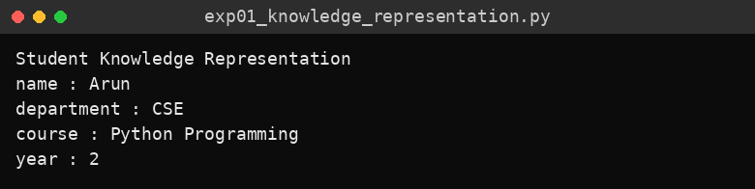
Console screenshot

Result
The student knowledge was successfully represented as attribute–value pairs and displayed on the console.

Experiment 2: Knowledge Acquisition from a Domain Expert

Aim
To acquire knowledge from a domain expert through user input and store it in a structured form.

Algorithm
- Start.
- Read the expert name, area of expertise and years of experience from the user.
- Convert the years of experience to an integer.
- Store the three values in a dictionary named knowledge.
- Display the acquired knowledge from the dictionary.
- Stop.

Code
name = input("Enter expert name: ")
domain = input("Enter area of expertise: ")
experience = int(input("Enter years of experience: "))

knowledge = {
"expert": name,
"domain": domain,
"experience": experience
}

print("\nAcquired Knowledge")
print("Expert:", knowledge["expert"])
print("Domain:", knowledge["domain"])
print("Experience:", knowledge["experience"], "years")

Output
Text output
Enter expert name: Dr. Ramesh
Enter area of expertise: Machine Learning
Enter years of experience: 12

Acquired Knowledge
Expert: Dr. Ramesh
Domain: Machine Learning
Experience: 12 years

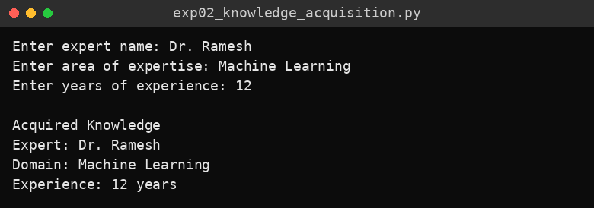
Console screenshot

Result
The expert’s name, domain and experience were acquired interactively and stored as a structured knowledge record.

Experiment 3: Course Recommendation using Rule-Based Logic

Aim
To recommend a course to a student based on the interest entered, using IF–ELIF–ELSE rules.

Algorithm
- Start.
- Read the interest (AI, Data or Web) and convert it to lower case.
- If the interest is “ai”, set the course to Artificial Intelligence.
- Else if the interest is “data”, set the course to Data Science.
- Else if the interest is “web”, set the course to Web Development.
- Otherwise, set the course to “No matching course found”.
- Display the recommended course.
- Stop.

Code
interest = input("Enter your interest (AI, Data, Web): ").strip().lower()

if interest == "ai":
course = "Artificial Intelligence"
elif interest == "data":
course = "Data Science"
elif interest == "web":
course = "Web Development"
else:
course = "No matching course found"

print("Recommended Course:", course)

Output
Test case 1 (input: AI)
Enter your interest (AI, Data, Web): AI
Recommended Course: Artificial Intelligence

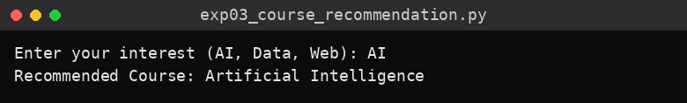
Console screenshot – test case 1
Test case 2 (input: web)
Enter your interest (AI, Data, Web): web
Recommended Course: Web Development

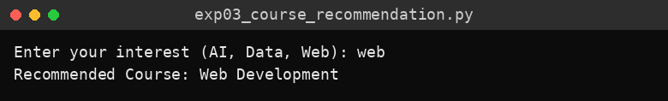
Console screenshot – test case 2
Test case 3 (input: cooking)
Enter your interest (AI, Data, Web): cooking
Recommended Course: No matching course found

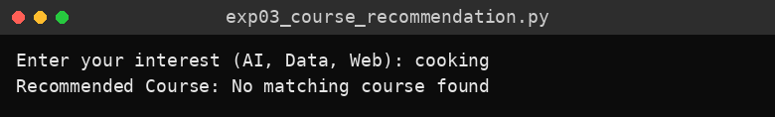
Console screenshot – test case 3

Result
The program recommended the appropriate course for each known interest and reported “No matching course found” for an unknown interest.

Experiment 4: Network Troubleshooting Expert System

Aim
To diagnose a basic network problem using a simple rule-based expert system.

Algorithm
- Start.
- Ask whether the internet can be accessed and read the answer (yes/no).
- Ask whether Wi-Fi is connected and read the answer (yes/no).
- If internet access is “yes”, diagnose that the connection is working.
- Else if Wi-Fi is “no”, advise checking the Wi-Fi settings or router power.
- Otherwise, advise checking router connectivity and network settings.
- Stop.

Code
internet = input("Can you access the internet? (yes/no): ").strip().lower()
wifi = input("Is Wi-Fi connected? (yes/no): ").strip().lower()

if internet == "yes":
print("Diagnosis: Internet connection is working.")
elif wifi == "no":
print("Diagnosis: Check Wi-Fi settings or router power.")
else:
print("Diagnosis: Check router connectivity and network settings.")

Output
Test case 1 (input: no, no)
Can you access the internet? (yes/no): no
Is Wi-Fi connected? (yes/no): no
Diagnosis: Check Wi-Fi settings or router power.

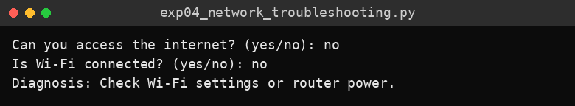
Console screenshot – test case 1
Test case 2 (input: yes, yes)
Can you access the internet? (yes/no): yes
Is Wi-Fi connected? (yes/no): yes
Diagnosis: Internet connection is working.

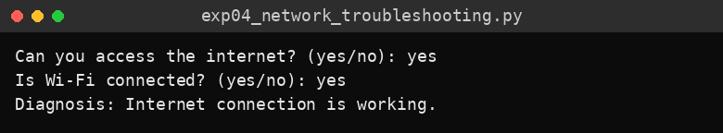
Console screenshot – test case 2
Test case 3 (input: no, yes)
Can you access the internet? (yes/no): no
Is Wi-Fi connected? (yes/no): yes
Diagnosis: Check router connectivity and network settings.

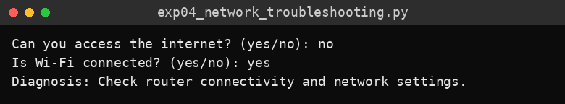
Console screenshot – test case 3

Result
The expert system gave the correct diagnosis for all three combinations of user answers tested.

Experiment 5: Semantic Network using NetworkX

Aim
To represent knowledge as a semantic network of concepts connected by labelled relationships using the NetworkX library.

Algorithm
- Start and import the networkx library.
- Create an empty directed graph.
- Add the edge Dog → Mammal with relation “is-a”.
- Add the edge Mammal → Animal with relation “is-a”.
- Add the edge Dog → Tommy with relation “has-instance”.
- Traverse all edges with their data and print each as source -- relation --> target.
- Stop.

Code
# Requires: pip install networkx
import networkx as nx

G = nx.DiGraph()
G.add_edge("Dog", "Mammal", relation="is-a")
G.add_edge("Mammal", "Animal", relation="is-a")
G.add_edge("Dog", "Tommy", relation="has-instance")

print("Semantic Network Relationships:")
for source, target, data in G.edges(data=True):
print(source, "--", data["relation"], "-->", target)

Output
Text output
Semantic Network Relationships:
Dog -- is-a --> Mammal
Dog -- has-instance --> Tommy
Mammal -- is-a --> Animal

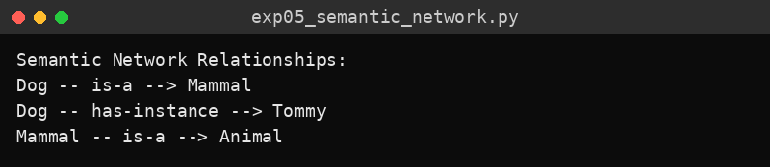
Console screenshot
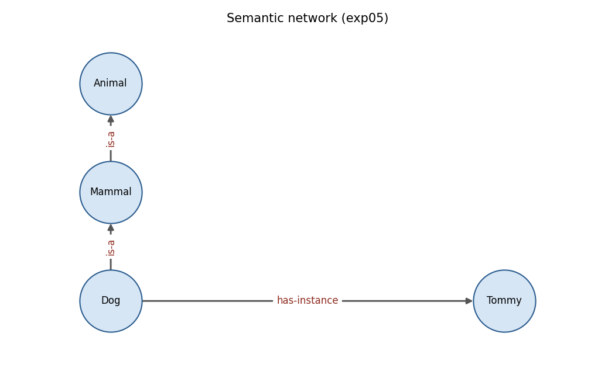
Figure: Semantic network drawn from the program’s graph

Result
The semantic network was created and its concept relationships (is-a and has-instance) were displayed successfully.

Experiment 6: Frame Representation of Knowledge

Aim
To represent knowledge about an object as a frame consisting of slots and slot values.

Algorithm
- Start.
- Create a dictionary named vehicle that acts as a frame, with slots class, brand, fuel_type, wheels and color.
- Fill each slot with its value.
- Loop through the slots and values of the frame.
- Print each slot name with its value.
- Stop.

Code
vehicle = {
"class": "Vehicle",
"brand": "Toyota",
"fuel_type": "Petrol",
"wheels": 4,
"color": "White"
}

print("Vehicle Frame")
for slot, value in vehicle.items():
print(slot, ":", value)

Output
Text output
Vehicle Frame
class : Vehicle
brand : Toyota
fuel_type : Petrol
wheels : 4
color : White

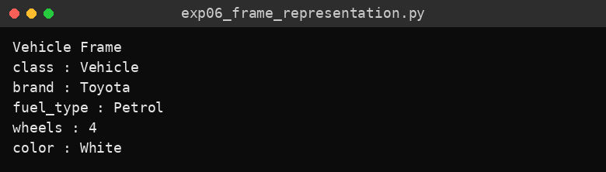
Console screenshot

Result
The Vehicle frame was created with its slots and values and displayed successfully.

Experiment 7: Forward Chaining Inference

Aim
To implement forward chaining, a data-driven inference method that derives new facts from known facts and rules.

Algorithm
- Start.
- Initialise the fact set with has_fever and has_cough.
- Define the rules: (has_fever, has_cough) → possible_flu and (possible_flu) → recommend_medical_review.
- Set changed = True and repeat while changed is True.
- In each pass, set changed = False and examine every rule.
- If all conditions of a rule are in the fact set and its conclusion is not, add the conclusion, print it and set changed = True.
- When no rule adds a new fact, stop the loop.
- Print the final set of facts.
- Stop.

Code
facts = {"has_fever", "has_cough"}
rules = [
({"has_fever", "has_cough"}, "possible_flu"),
({"possible_flu"}, "recommend_medical_review")
]

changed = True
while changed:
changed = False
for conditions, conclusion in rules:
if conditions.issubset(facts) and conclusion not in facts:
facts.add(conclusion)
print("Inferred:", conclusion)
changed = True

print("\nFinal Facts:")
for fact in sorted(facts):
print(fact)

Output
Text output
Inferred: possible_flu
Inferred: recommend_medical_review

Final Facts:
has_cough
has_fever
possible_flu
recommend_medical_review

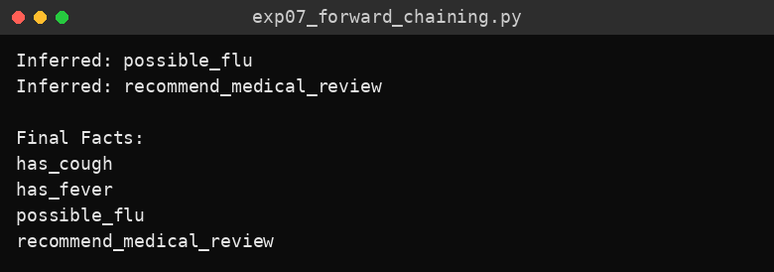
Console screenshot

Result
Forward chaining inferred possible_flu and then recommend_medical_review from the initial facts, and the final fact base was displayed.

Experiment 9: Knowledge Graph using NetworkX

Aim
To build a small knowledge graph of entities and relationships, and list its subject–relation–object triples.

Algorithm
- Start and import the networkx library.
- Create an empty directed graph named knowledge_graph.
- Add the edge Arun → Python with relation “studies”.
- Add the edge Arun → Computer Science with relation “belongs_to”.
- Add the edge Python → Programming Language with relation “is_a”.
- Iterate over all edges and print each triple as subject -- relation --> object.
- Stop.

Code
# Requires: pip install networkx
import networkx as nx

knowledge_graph = nx.DiGraph()
knowledge_graph.add_edge("Arun", "Python", relation="studies")
knowledge_graph.add_edge("Arun", "Computer Science", relation="belongs_to")
knowledge_graph.add_edge("Python", "Programming Language", relation="is_a")

print("Knowledge Graph Triples:")
for subject, obj, data in knowledge_graph.edges(data=True):
print(subject, "--", data["relation"], "-->", obj)

Output
Text output
Knowledge Graph Triples:
Arun -- studies --> Python
Arun -- belongs_to --> Computer Science
Python -- is_a --> Programming Language

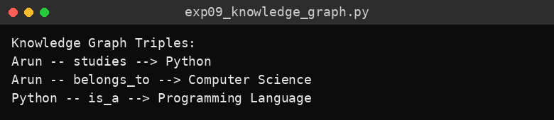
Console screenshot
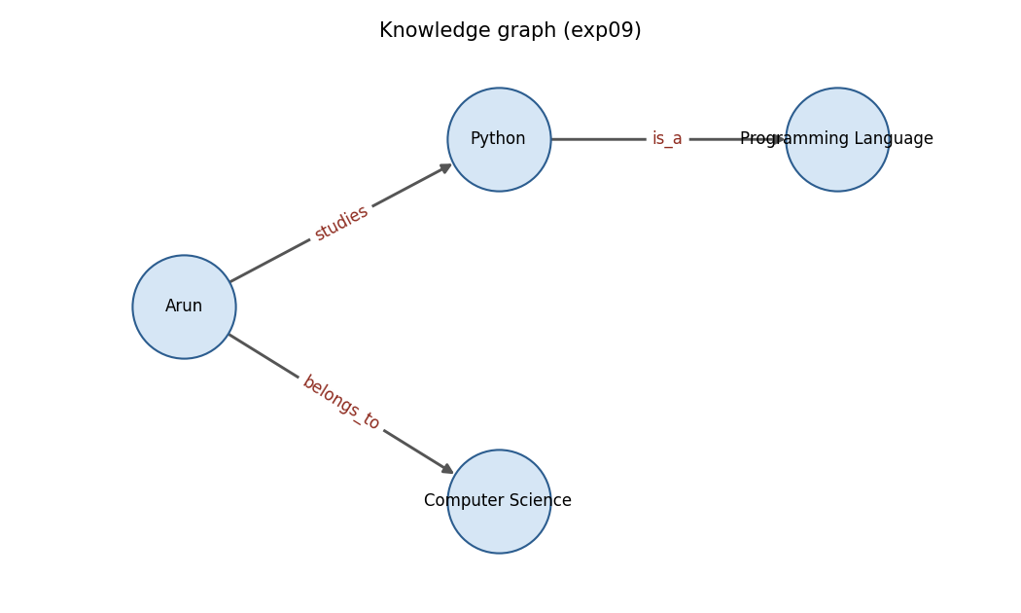
Figure: Knowledge graph drawn from the program’s graph

Result
The knowledge graph was constructed and its triples were displayed successfully.

Experiment 10: Knowledge Management System

Aim
To build a simple knowledge management system that stores topics and retrieves their descriptions on request.

Algorithm
- Start.
- Create a dictionary knowledge_base with topics as keys and their descriptions as values.
- Display the list of available topics.
- Read the topic to be searched and convert it to lower case.
- If the topic is a key in the knowledge base, display its description.
- Otherwise, display “No information found for this topic.”
- Stop.

Code
knowledge_base = {
"python": "Python is a high-level programming language.",
"ontology": "An ontology formally defines concepts and relationships.",
"knowledge graph": "A knowledge graph connects entities through relationships.",
"expert system": "An expert system uses rules and knowledge to solve problems."
}

print("Knowledge Management System")
print("Available topics:", ", ".join(knowledge_base.keys()))
query = input("\nEnter a topic to search: ").strip().lower()

if query in knowledge_base:
print("Knowledge Found:")
print(knowledge_base[query])
else:
print("No information found for this topic.")

Output
Test case 1 (input: ontology)
Knowledge Management System
Available topics: python, ontology, knowledge graph, expert system

Enter a topic to search: ontology
Knowledge Found:
An ontology formally defines concepts and relationships.

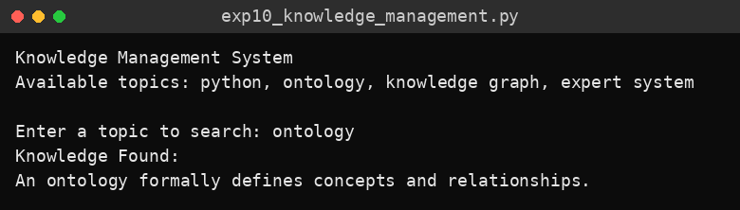
Console screenshot – test case 1
Test case 2 (input: robotics)
Knowledge Management System
Available topics: python, ontology, knowledge graph, expert system

Enter a topic to search: robotics
No information found for this topic.

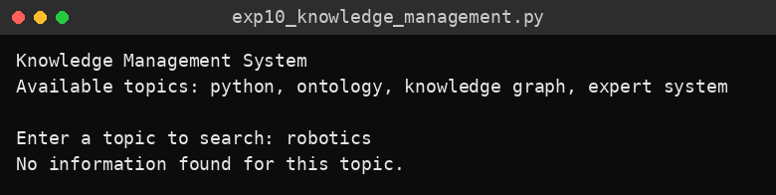
Console screenshot – test case 2

Result
The system retrieved the stored knowledge for an available topic and reported correctly when a topic was not present.

Experiment 11: RDF Knowledge Triples using rdflib

Aim
To represent knowledge as RDF triples (subject, predicate, object) using the rdflib library.

Algorithm
- Start and import Graph, Namespace and Literal from rdflib.
- Create an empty RDF graph and define the namespace http://example.org/.
- Add the triple (Arun, studies, Python).
- Add the triple (Python, type, “Programming Language”).
- Iterate over the graph and print each subject, predicate and object.
- Stop.

Code
# Requires: pip install rdflib
from rdflib import Graph, Namespace, Literal

g = Graph()
EX = Namespace("http://example.org/")

g.add((EX.Arun, EX.studies, EX.Python))
g.add((EX.Python, EX.type, Literal("Programming Language")))

print("RDF Knowledge Triples:")
for subject, predicate, obj in g:
print(subject, predicate, obj)

Output
Text output
RDF Knowledge Triples:
http://example.org/Python http://example.org/type Programming Language
http://example.org/Arun http://example.org/studies http://example.org/Python

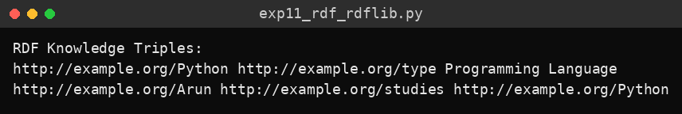
Console screenshot
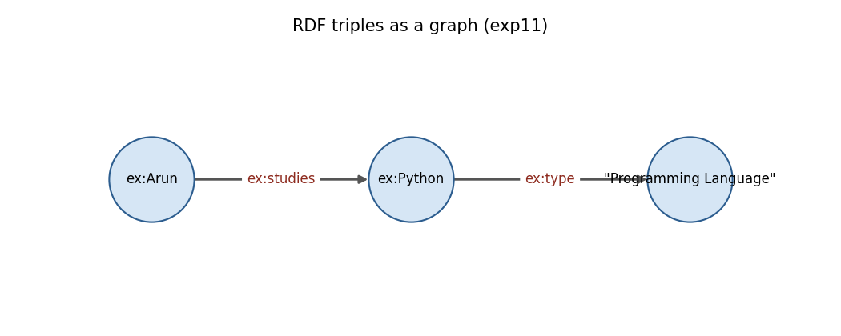
Figure: RDF triples shown as a graph

Result
The RDF graph was created and its triples were printed. rdflib does not guarantee triple order, so the order of the lines may differ between runs.

Experiment 12: Graph Traversal – Finding the Connection between Entities

Aim
To find the shortest connection path between two entities in a knowledge graph using graph traversal.

Algorithm
- Start and import the networkx library.
- Create an undirected graph and add the edges Arun–Python, Python–Programming, Programming–Computer Science and Arun–College.
- Read the starting entity and the target entity from the user.
- Find the shortest path between them using nx.shortest_path().
- If a path exists, print it with the nodes joined by “ -> ”.
- If no path exists or a node is not in the graph, print “No path found between the given entities.”
- Stop.

Code
# Requires: pip install networkx
import networkx as nx

G = nx.Graph()
G.add_edges_from([
("Arun", "Python"),
("Python", "Programming"),
("Programming", "Computer Science"),
("Arun", "College")
])

start = input("Enter starting entity: ").strip()
target = input("Enter target entity: ").strip()

try:
path = nx.shortest_path(G, source=start, target=target)
print("Connection Path:", " -> ".join(path))
except (nx.NetworkXNoPath, nx.NodeNotFound):
print("No path found between the given entities.")

Output
Test case 1 (input: Arun, Computer Science)
Enter starting entity: Arun
Enter target entity: Computer Science
Connection Path: Arun -> Python -> Programming -> Computer Science

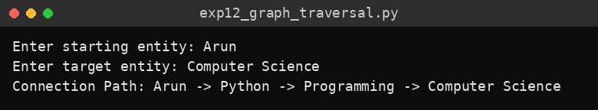
Console screenshot – test case 1
Test case 2 (input: Arun, Robotics)
Enter starting entity: Arun
Enter target entity: Robotics
No path found between the given entities.

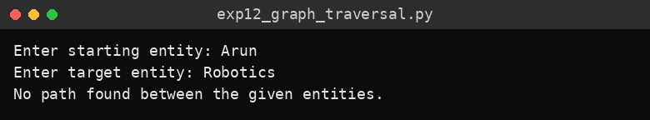
Console screenshot – test case 2
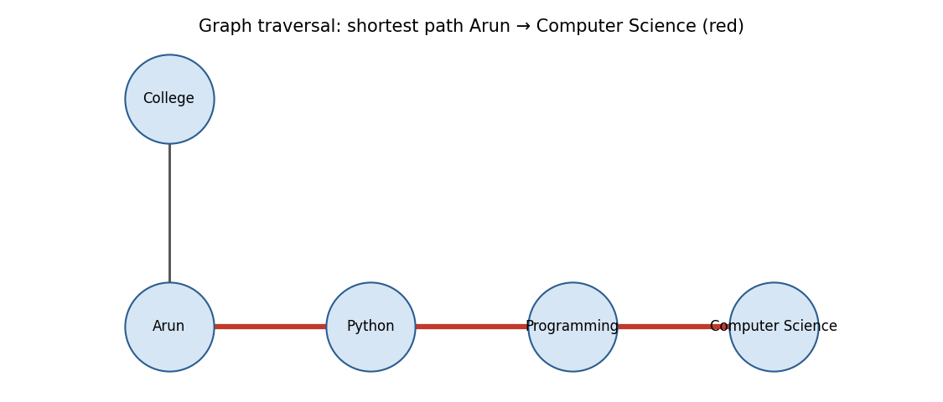
Figure: Shortest path from Arun to Computer Science highlighted in red

Result
The program found the shortest connection path between related entities and reported correctly when no path existed.

